September 3, 2026 Lab 03 – Introduction to GitHub and C Programming Language.
Student Name: Laksh Kumar Roll No:26k-0672 Section: BCS-1D

Prepared By: Miss Izzah Salam | Introduction to GitHub and C Programming Language 1
Question 1:
Write a C program to print a simple detail on the screen. Name, age, department, Student ID,
Section and University name.
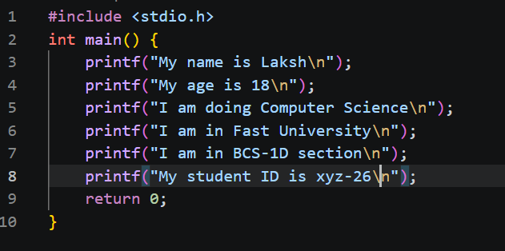
Question 2:
Write a C Program to take input from user. It should be Name, age, department, Student ID
University name and then display details
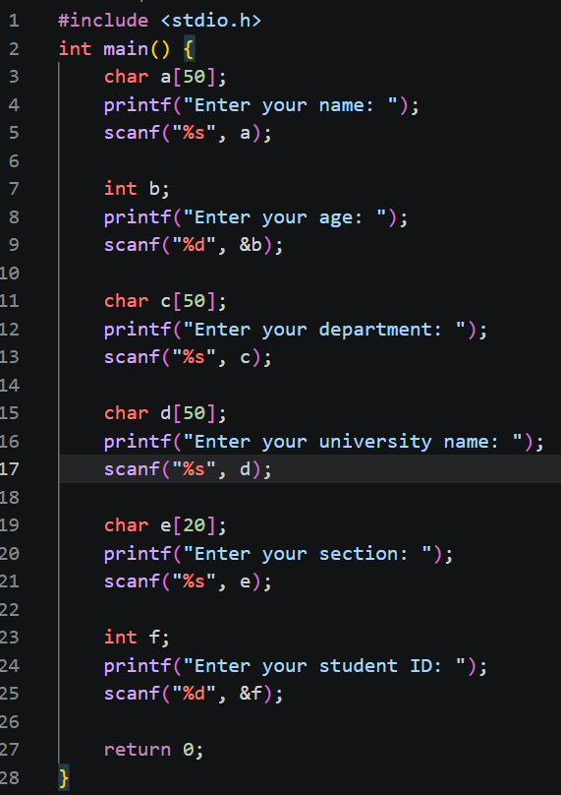

Question:3
Write a C program that takes a distance in kilometers from the user and converts it to meters and
centimeters.
(1 km = 1000 meters, 1 meter = 100 centimeters)
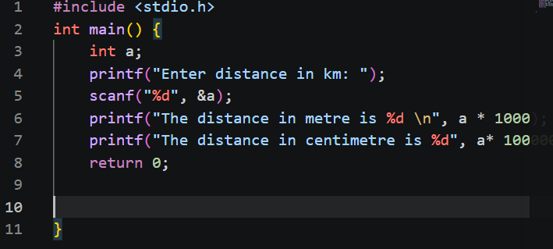

Question:4
Write a C program to calculate the area of a triangle. Take base and height as input from user.
(Formula: Area = 0.5 * base * height)
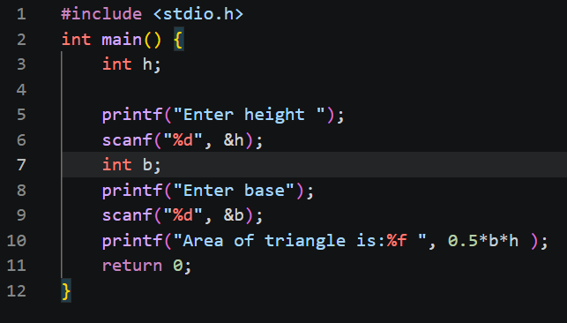

Question:5
Write a C program that takes two numbers as input and swaps their values without using a third
Variable
